Q1.

1. C:\Users\Umesha\Desktop\HW1
2. **Dimension of the matrix:**

Number of Rows = 21

Number of columns = 5

Q2.

1. #f) Scatter plot

plot(cars$MPG_Highway,cars$MSRP,xlab = "Highway Mileage",ylab = "MSRP ($)",main = "MSRP VS Highway Mileage")

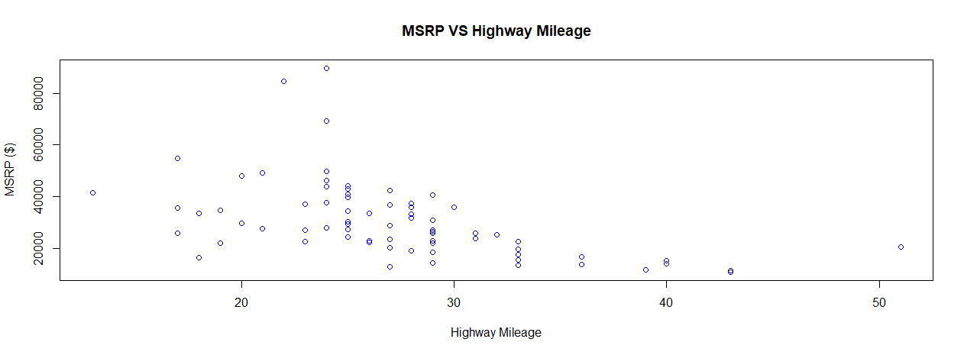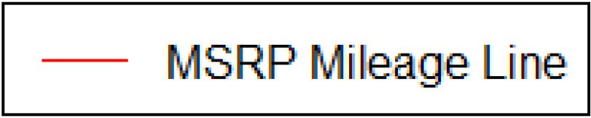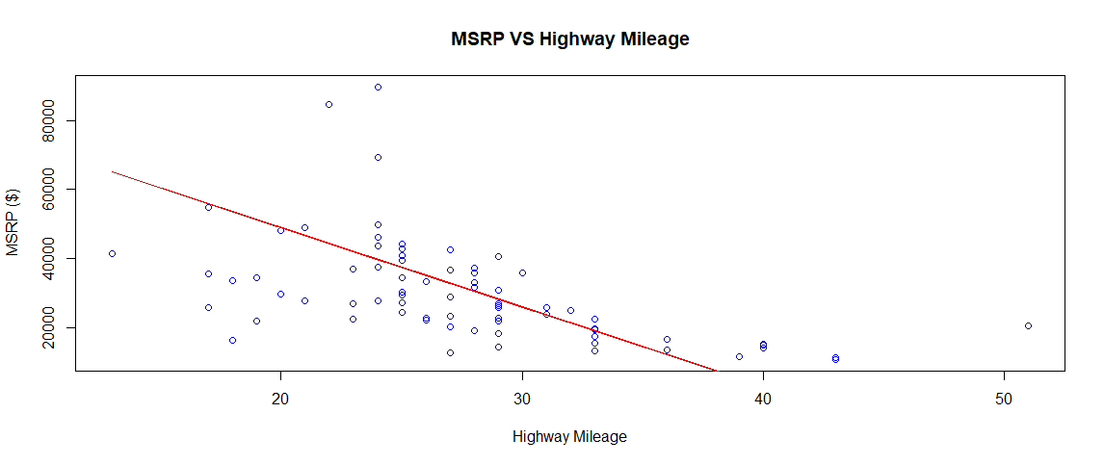

1. sumf(a1) = 6

sumf(a2) = "Non-numeric or length is less than 3"

sumf(a3) = "Non-numeric or length is less than 3"